E-match Connectors

One of the best ways to connect an E-match and a great boost to safety.

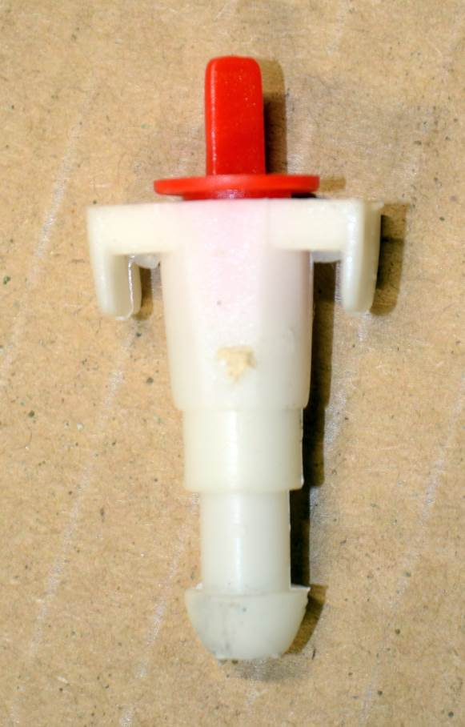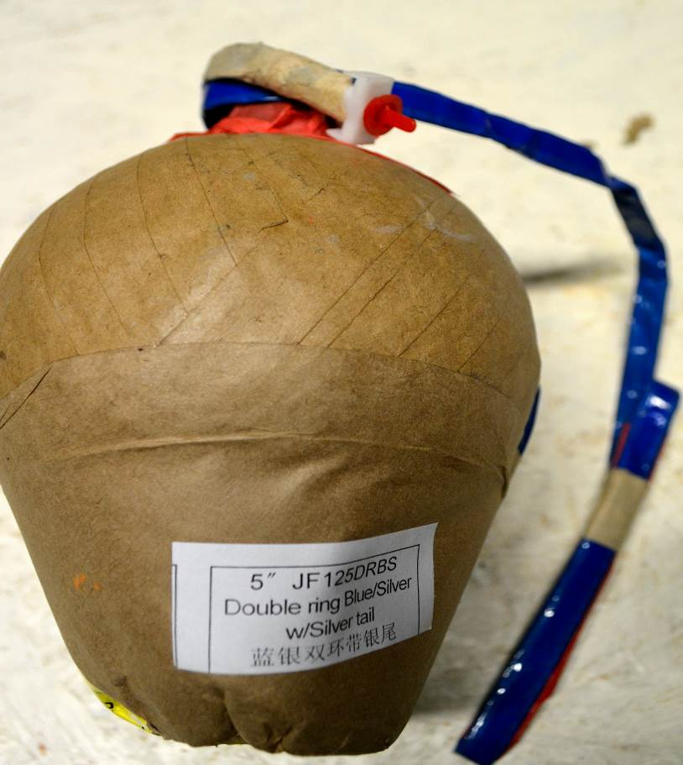

They are basic devices made of plastic, and yet provide a simple yet effective way of connecting E-matches to fireworks.
Many fireworks today arrive from the factories with connectors already fitted

Below is a sequence showing the connection of an E-match to a connector …

